WHAT DOES THE FIRST NATIONAL BANK OF FORT SMITH DO WITH YOUR PERSONAL INFORMATION?
FACTS
Approved Aug 2024, Effective Sept 2024

Financial companies choose how they share your personal information. Federal law gives consumers the right to limit some but not all sharing. Federal law also requires us to tell you how we collect, share, and protect your personal information. Please read this notice carefully to understand what we do.
Why?
The type of personal information we collect and share depends on the product or service you have with us. This information includes:
- Social Security Number and Account Transactions
- Account Balances and Payment History
- Income and Credit History
When you are no longer our customer, we continue to share your information as described in this notice.

What?
All financial companies need to share customer's personal information to run their everyday business. In the section below, we list the reasons financial companies can share their customer's personal information; the reasons The First National Bank of Fort Smith chooses to share; and whether you can limit this sharing.
How?

Reasons we can share your personal information | Does The First National Bank of Fort Smith share? | Can you limit this sharing?
For our everyday business purposes ‐  such as to process your transactions, maintain your account(s), respond to court orders and legal investigations, or report to  credit bureaus. | YES | NO
For our marketing purposes ‐  to offer our products and services to you | YES | NO
For joint marketing with other financial companies | NO | We Don't Share
For our affiliates' everyday business purposes ‐  information about your transactions and experiences | YES | NO
For our affiliates' everyday business purposes ‐  information about your creditworthiness | YES | YES
For our affiliates to market to you | YES | YES
For Nonaffiliates to market to you | NO | We Don't Share
- Call 479‐788‐4600 or
- Visit us online: www.fnbfs.com/privacy
Please Note: If you are a new customer, we can begin sharing your information 30 days from the date we sent this notice. When you are no longer our customer, we continue to share your information as described in this notice. However, you can contact us at any time to limit our sharing.
To limit our sharing

Questions? | Call (479) 788 – 4600 or go to www.fnbfs.com/privacy

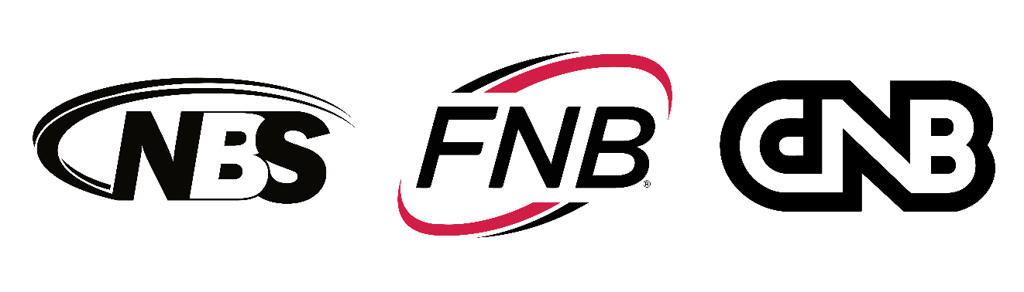
Member FDIC

Page 2

Who we are
Who is providing this notice? | The First National Bank of Fort Smith.  First National Bank of NWA, a division of The First National Bank of Fort Smith. National Bank of Sallisaw, a division of The First National  Bank of Fort Smith and The Central National Bank of Poteau, a division of The First National Bank of Fort Smith.

What do we do
How does The First National Bank of Fort Smith protect my personal Information? | To protect your personal information from unauthorized access and use, we use security measures that comply with federal law. These measures include computer safeguards and secured files and  buildings.
How does The First National Bank of Fort Smith collect my personal information? | We collect your personal information, for example, when you  - Open an account or apply for a loan.  - Make a wire transfer or give us your contact information.  - Provide account information.  We also collect your personal information from others, such as credit  bureaus, affiliates, or other companies.
Why can't I limit all sharing? | Federal law gives you the right to limit only  - Sharing for affiliates' everyday business purposes ‐‐ information about your creditworthiness.  - Affiliates from using your information to market to you.  - Sharing for nonaffiliates to market to you.  State laws and individual companies may give you additional rights to  limit sharing.
What happens when I limit sharing for an account I hold jointly with someone else? | Your choices will apply to everyone on your account—unless you tell us otherwise.

Definitions
Affiliates | Companies related by common ownership or control. They can be financial and nonfinancial companies:  Our affiliates include First Bank Corp (Financial Holding Company) which owns a controlling interest in the financial companies: The First National Bank of Fort Smith and Citizens Bank and Trust Company. First Bank Corp also owns a controlling interest in the nonfinancial company, Realty Appraisals Inc.
Nonaffiliates | Companies not related by common ownership or control. They can be financial and nonfinancial companies.  - The First National Bank of Fort Smith does not share with nonaffiliates so they can market to you.
Joint marketing | A formal agreement between nonaffiliated financial companies that together market financial products or services to you.  - The First National Bank of Fort Smith does not jointly market.

